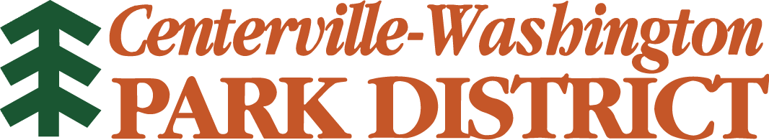

Athletic Release Agreement

I hereby, for myself and/or my child understand the risks involved and hereby consent for myself and/or my child to participate in activities and/or use the facilities of the Centerville-Washington Park District. I hereby release, indemnify, and hold harmless the Centerville-Washington Park District, its Commissioners, Agents, Employees and Assignees from any and all liability claims, actions, demands and judgments arising out of injury or loss sustained by me or my child while participating in activities or using facilities of the Centerville-Washington Park District.

Signature (parent or guardian if under age 18) Date

Participant’s Name

Parent or Guardian

Street

City, Zip

Sport

Coach

